**Specialist Mathematics Units 3 & 4**

**Test 6 2017**

**Calculator Section Only**

**Name: _______________________ Score: _____ / 59**

**Calculators allowed and 1 page of A4 notes, writing on both sides.**

**Access to approved Mathematics Specialist formulae sheet is permitted. Time limit = 55 minutes**

**Question 1 (3, 4) (7 marks)**

If the numbers 1 to 50 forms the population, then the population mean is 25.5 and standard deviation is 14.43.

(a) If all possible samples of size 30 were taken from this population, what does the Central Limit theorem tell us about the distribution of the means of these samples?

(b) The diagram below shows 2 lists of 30 randomly generated counting numbers from 1 to 50 generated by the calculator.

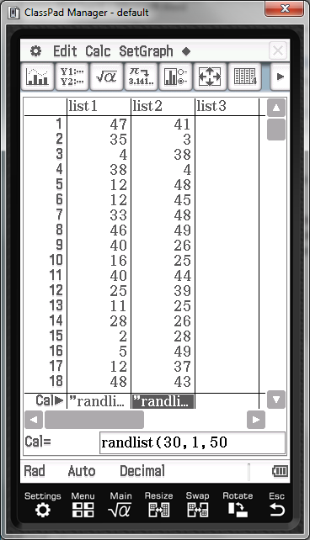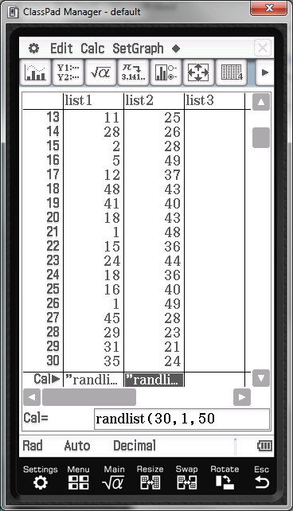

Given that the 95% confidence interval for the population mean is 16.99  34.01, indicate whether these lists above are representative samples, giving your reasons.

**Question 2 (3, 3, 2, 3, 2) (13 marks)**

Smiths Co. sells potato chips in packets labelled as 450g. It is known that the amount of potato chips in each pack is normally distributed with mean 449g and standard deviation 2g.

1. Find, with reasons, the probability that a randomly chosen pack of potato chips has a mass less than 450g.
2. Find, with reasons, the probability that a randomly selected sample of 40 packs of potato chips has a mean of less than 450g.
3. Comment on your answers in (a) and (b).
4. Find, with reasons, the probability that a randomly selected sample of 30 packs of potato chips has a total mean of at least 13.48 kg.
5. Determine the size *n* of a random sample if the standard deviation of the sampling distribution is to be less than 0.25g.

**Question 3 (2, 4, 1, 3, 2, 1) (13 marks)**

Let µ and σ be the mean mass of locally grown carrots and its associated standard deviation.

1. The masses of a random sample of 150 carrots are measured. The mean mass for this sample is 85.67g with a sample standard deviation of 7.3g.
   1. Find a point estimate for µ and σ. Justify your answer.
   2. Find a 95% and a 99% confidence interval for µ.
   3. Comment on the statistical implications of the differing widths of the two intervals in ii.
2. For σ = 7.3, find the sample size *n* such that the 90% confidence interval for µ:
   1. has width 3g.
   2. has width 1g.
   3. Comment on the statistical implications of the differing widths of the two intervals in i. and ii. for a given level of confidence.

Question 4 (1, 2, 2, 3) (8 marks)

A particle moves along the -axis, with displacement *x* cm from the origin, after *t* seconds, given by , where *a* is a positive constant. After 1 second, the particle is 12 cm from the origin.

1. Find the value of *a.*
2. Show that the motion of the particle is simple harmonic.
3. Find the speed of the particle as it passes through the origin.

(d) Find the distance travelled by the particle during the first minute of its motion.

**Question 5 (3, 3, 3) (9 marks)**

The acceleration of a particle P undergoing rectilinear motion is given by  ms-2. The initial velocity of P is  ms-1.

1. Calculate the exact velocity of P when *t* = 12 seconds.
2. Find the exact average speed of P during the first 12 seconds.
3. Find the average acceleration of P during the first 12 seconds.

**Question 6 (3, 3, 3) (9 marks)**

The time taken to serve customers in drive through at a fast food restaurant is a random variable with a mean of 3.5 minutes with a variance of 4 minutes.

1. Estimate the probability that:
   1. The time taken to serve a random sample of 25 successive customers exceeds 70 minutes.
   2. No more than 130 minutes is required to serve a random sample of 35 successive customers.
2. The probability that the time taken to record 50 successive transactions does not exceed *k* minutes is approximately 0.1. Find *k.*

End of Test